ANGLE FLYING
COMPETITION RULE BOOK
DIVE POOL & REGULATIONS

Presented by Downunder Dynamics
www.downunderdynamics.com.au

Contents
Contents 1
1. Discipline Overview 1
2. Purpose 1
3. Key Rules and Guidelines 1
Navigation and Line of Flight 1
3.1 Line Definition and Direction 1
3.2 Camera Position 1
3.3 Group Exit and Line Separation 1
3.4 Judging Line and Opening Location 1
3.5 Simplicity and Efficiency 1
Navigation and Line of Flight Scoring 1
3.6 Minor Navigation Fault — 0.5 Point Deduction 1
3.7 Major Navigation Fault — 1 Point Deduction 1
3.8 Safety Violation — 2 Point Deduction or Disqualification 1
3.9 Non-Scorable Navigation 1
Docks 1
Video Requirements 1
Body Positions 1
Judging Criteria 1
Scoring 1
4. Skill Levels and Dive Pool Allocation 1
5. Skill Level Selection Criteria 1
Beginner Class 1
Intermediate Class 1
Advanced Class 1
Open Class (Optional) 1
6. Dive Pool 1
6.1 Randoms — Visual Reference 1
6.2 Randoms — Descriptions 1
6.3 Blocks — Visual Reference 1
6.4 Blocks — Descriptions 1
7. Safety and Conduct 1
8. Amendments and Updates 1

1. Discipline Overview
Angle flying is a dynamic discipline within body flight that combines horizontal and vertical navigation through space while maintaining formation control and precise synchronisation between flyers.

Unlike static disciplines, angle flying emphasises movement, spatial awareness, and coordinated control while flying in formation across a defined line of flight.

This document outlines the competition structure, rules, and dive pool for competitive angle flying, providing a standardised system for judging, safety, and skill development.

2. Purpose
The Angle Flying Dive Pool and its accompanying rules are designed to:
- Provide a shared vocabulary and structure for competitive angle flying.
- Promote safe and progressive flying through clearly defined tasks.
- Encourage teamwork, discipline, and high-quality flying standards.
- Support future development of advanced sequences and formations.

3. Key Rules and Guidelines

Navigation and Line of Flight
Navigation is a defining element of angle flying. Every jump must demonstrate intentional, continuous movement across the sky on a defined line of flight. Judging focuses on direction, separation, and safety — not pitch or body angle.

3.1 Line Definition and Direction
- All randoms and blocks must be performed while actively flying a clear horizontal line.
- The line of flight is the intended horizontal direction the group travels from exit to break-off.
- Judges assess navigation based on ground references visible in the video (roads, runways, fields, etc.) and the declared flight plan.
- Camera flyers should film slightly above and offset to provide a clear perspective of both flyers and the ground line.

3.2 Camera Position
- The camera flyer's goal is to show direction of travel and docks, not to chase or mark visually.
- Ideal framing includes both competitors and visible ground reference throughout working time.
- Judges must be able to see the docks, all transition, continuous forward movement, maintained heading, and the break-off or separation direction.

3.3 Group Exit and Line Separation
To ensure safety and judging clarity:
- A maximum of three groups may exit per aircraft pass.
- One group may fly left, one right, and one straight along jump run (if last out).
- Groups flying left or right may veer no less than 45° from jump run.
If upper winds are crosswind to jump run:
- A maximum of two groups may exit per pass.
- Both must fly the same direction, separated as the first and last exits on that pass.

3.4 Judging Line and Opening Location
- Judges assess the line of flight based on visible ground references and declared direction.
- Opening areas must align with the group's declared line.
- Openings drifting toward other groups' airspace or back toward jump run are navigation faults or safety penalties.
Judges confirm that:
- The line was defined and maintained.
- The group opened within their intended airspace.
- No overlap occurred between groups' flight paths.

3.5 Simplicity and Efficiency
Navigation is judged qualitatively — visually, not by measurement. Judges confirm:
- The group flew a consistent and visible line.
- Break-off and openings matched the declared direction.
- Direction matched the stated plan (left, right, or straight).
No additional markers or equipment are required.

Navigation and Line of Flight Scoring
Judges apply navigation penalties only when a rule breach affects safety, spacing, or the integrity of the skydive.

3.6 Minor Navigation Fault — 0.5 Point Deduction
Applied when:
- The group drifts or curves off its declared line but remains in its airspace.
- The line direction is unclear due to camera framing.
- Openings are safe but the flown line was inconsistent.

Deduction
−0.5 points per jump

3.7 Major Navigation Fault — 1 Point Deduction
Applied when:
- The group's line crosses or merges toward another group's.
- The group flies less than 45° off jump run or declared line.
- Wrong exit direction or sequence in crosswind conditions.
- Opens in incorrect airspace relative to declared line.
- The group flies more than 120° off jump run

Deduction
−1.0 point per jump

3.8 Safety Violation — 2 Point Deduction or Disqualification
Applied when:
- Navigation results in unsafe proximity between groups.
- Openings occur within or toward another group's airspace.
- Reported breach of separation protocols or deliberate disregard of exit order.

Deduction
−2.0 points per jump, or Disqualification for severe breaches

3.9 Non-Scorable Navigation
If navigation cannot be confirmed (e.g., poor camera angle, no visible ground), the round is marked Non-Scorable for Navigation. Other judged elements remain valid.

Summary of navigation penalties:

Fault Type | Description | Deduction
Minor | Slight drift or unclear line | −0.5 pts
Major | Wrong direction, line merge, incorrect exit | −1.0 pt
Safety | Loss of separation, unsafe openings | −2.0 pts or DQ
Non-Scorable | No visible line reference | No nav score applied

Docks
All docks must show intentional, visible contact between designated body parts as defined in the dive pool. Judges score only clear, deliberate docks, incidental or partial contact does not count.

- Docks must be executed cleanly and in frame.
- Contact must match the dive pool description (e.g., hand-to-hand, foot-to-chest).
- Both flyers must display control before and after contact.
- If the dock is unclear or obstructed, it will not be scored.

Video Requirements
- All jumps must be filmed from the side or above to ensure a clear view of both flyers and docks.
- Double docks must be shown clearly in one frame.
- If docks are not visible, the move will not be scored.
- For blocks, both performers must remain in frame throughout the sequence.

Body Positions
- Descriptions reference flyer orientation (belly, back, head up, head down) and position relative to each other.
- Dock direction (e.g., left-to-right or right-to-left) must match the dive pool description.

Judging Criteria
Judges evaluate:
- Correct execution of docks.
- Timing and synchronisation.
- Body control and precision.
- Line quality and navigation integrity.
- Visibility and clarity of footage.

Scoring
- Randoms: 1 point each.
- Blocks: 2 points each.
- Penalties: Applied per section above.

4. Skill Levels and Dive Pool Allocation
To maintain fairness and progression, the dive pool is divided into four skill levels — Beginner, Intermediate, and Advanced, with an optional Open category.

Level | Dive Pool Access | Competitor Profile
Novice | Randoms A, B, C only | New competitors developing fundamental line control and basic formation awareness. No prior block experience required.
Beginner | Randoms A–J only | New competitors developing fundamental line control and basic formation awareness. No prior block experience required.
Intermediate | Randoms A–J + Blocks 1–6 | Flyers with established angle experience. Must show consistent slot positioning and linked rotations.
Advanced | All Randoms (A–R) + Blocks 1–18 | Skilled competitors proficient in HU and HD angles. Strong awareness and synchronization required.
Open (Optional) | All Randoms (A–R) + Blocks 1–18 | Elite athletes with mastery of the full dive pool. Complex transitions, through-the-vert moves, and precise control.

5. Skill Level Selection Criteria
Competitors must nominate their class at registration. The Competition Director or Chief Judge may reassign competitors based on ability or prior experience.

Novice
- For new competitors with Belly flying experience only.
- Must demonstrate basic stability, navigation, and safe proximity.
- No prior block experience required.

Beginner Class
- For new competitors or those with limited formation experience.
- Must demonstrate basic stability, navigation, and safe proximity.
- No prior block experience required.

Intermediate Class
- For flyers with established angle experience and control across multiple orientations.
- Must show consistent slot positioning and linked rotations.
- Recommended prior training or team experience.

Advanced Class
- For skilled competitors capable of executing all Randoms and Blocks.
- Proficient in head-up and head-down angles with strong awareness and synchronisation.
- Commonly includes instructors or seasoned competitors.

Open Class (Optional)
- Reserved for elite athletes with mastery of the full dive pool.
- Demonstrates complex transitions, through-the-vert moves, and precise control.
- May include national or international level flyers.

6. Dive Pool
The dive pool is divided into Randoms (1 point each) and Blocks (2 points each). The visual reference pages below show the formations. Detailed descriptions follow each set of diagrams.

6.1 Randoms — Visual Reference
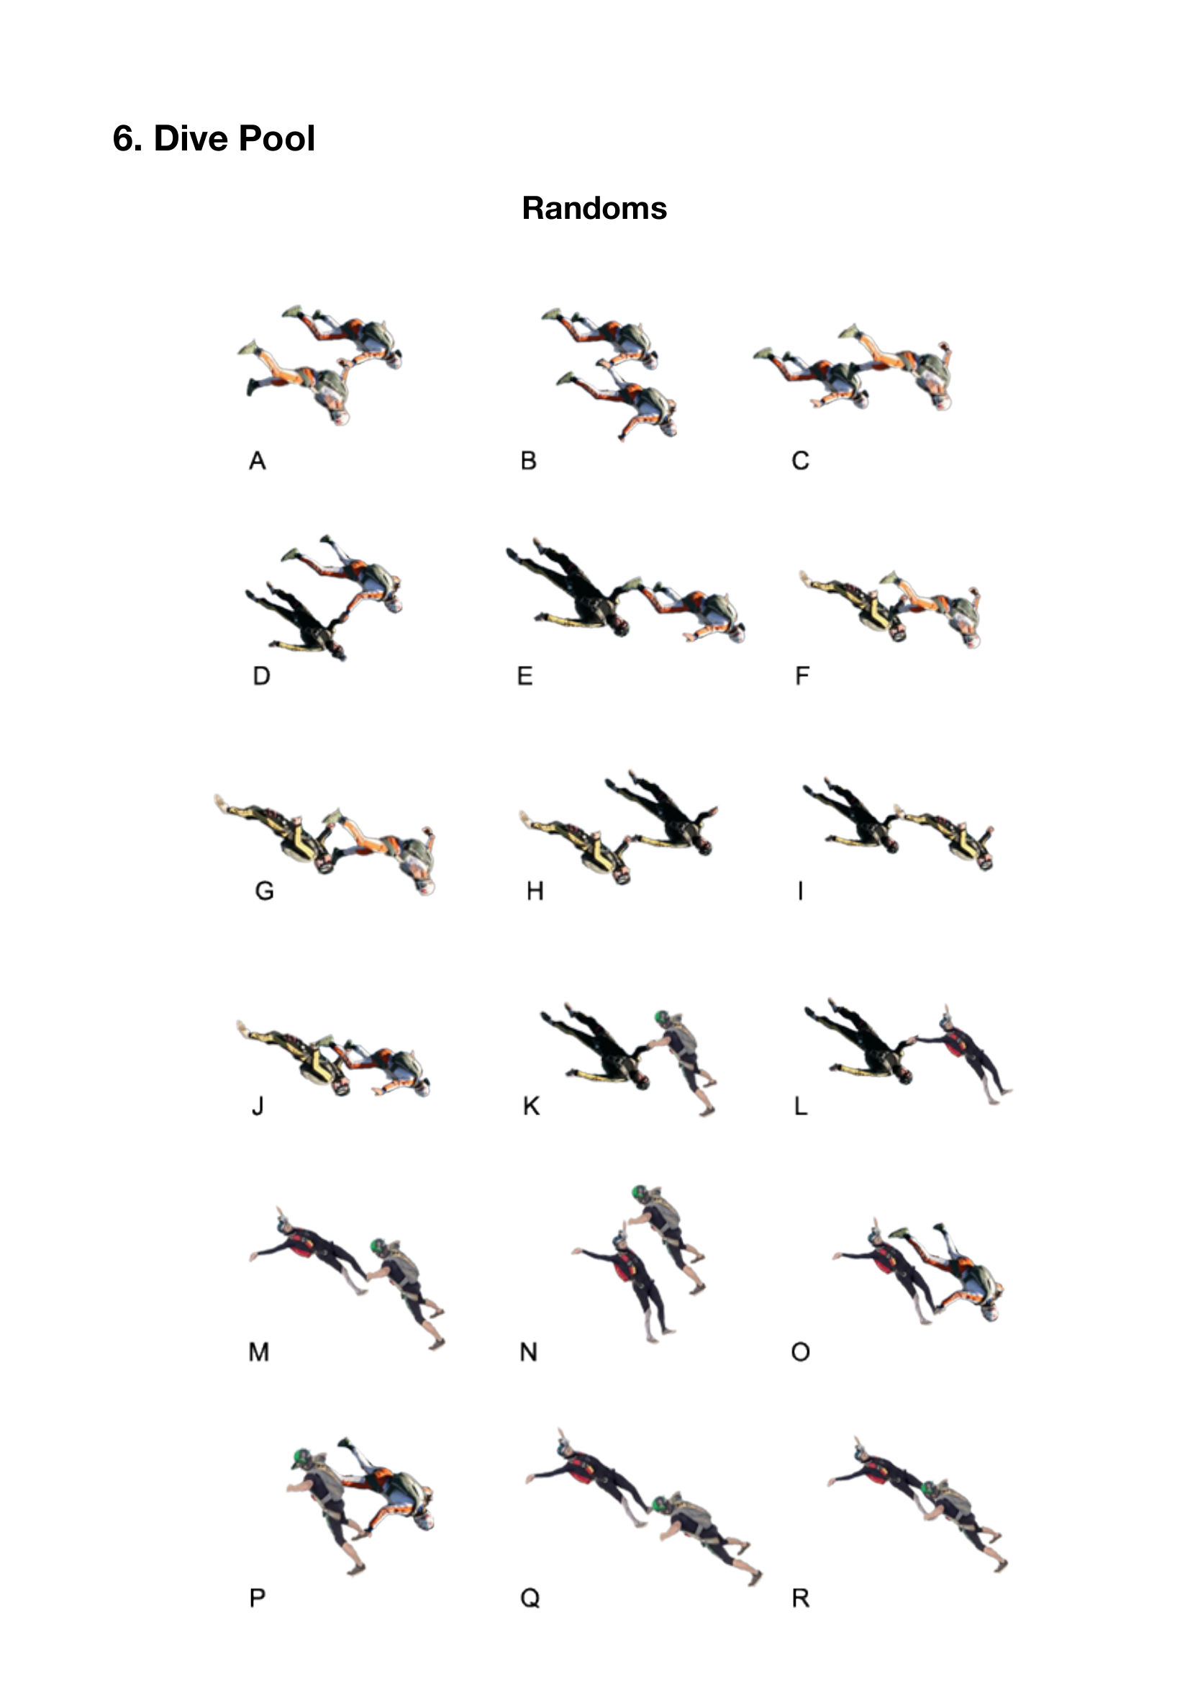

6.2 Randoms — Descriptions
All randoms require clear dock visibility filmed from the side or above.

Ref | Name | Description
A | Both Belly — Hand Dock | Both on belly, docking opposite hands (L→R or R→L)
B | Both Belly — Hand to Foot Dock | Both on belly, 1 flyer docks side-by-side on other's foot (L hand→R foot or R hand→L foot)
C | Both Belly — Foot to Container Dock | Both on belly, 1 flyer places foot on other's container
D | Back & Belly — Hand to Hand Dock | One back one belly, same side hand dock (R→R or L→L)
E | Back & Belly — Foot to Hand Dock | One back one belly, back flyer docks same side foot (L→L or R→R)
F | Back & Belly — Foot to Chest Dock | One back one belly, belly flyer places foot on back flyer's chest
G | Back & Belly — Foot to Head Dock | One back one belly, back flyer places head on belly flyer's foot
H | Both Back — Hand Dock | Both on back, docking opposite hands
I | Both Back — Hand to Foot Dock | Both on back, 1 flyer docks side-by-side on other's foot
J | Back & Belly — Double Hand to Foot Dock | One back one belly, back flyer docks both hands on both feet of belly flyer
K | Back HD to Belly HU — Hand to Hand Dock | Back HD flyer flies up to belly HU, docks opposite hand (L→R or R→L)
L | Back HD to Back HU — Hand to Hand Dock | HD back flyer flies up to HU flyer, docks same hand (L→L or R→R)
M | HU Angle Back & Belly — Foot to Hand Dock | One back one belly HU, belly docks same side foot of back flyer (R→R or L→L)
N | HU Angle Back & Belly — Hand to Hand Dock | One back one belly HU, same side hand dock (L→L or R→R)
O | HD Belly on HU Back — Foot Dock | Belly HD flies down side-by-side to dock on opposite foot of back HU (R→L or L→R)
P | HD Belly on HU Belly — Foot Dock | Belly HD flies down side-by-side to dock on same side foot of belly HU (R→R or L→L)
Q | HU Angle Back & Belly — Foot to Head Dock | One back one belly HU, back flyer places foot on belly flyer's head
R | HU Angle Back & Belly — Double Hand to Foot Dock | One back one belly HU, belly flyer docks both hands on both feet of back flyer

6.3 Blocks — Visual Reference
Blocks 1–6 (belly/back angle orientations):
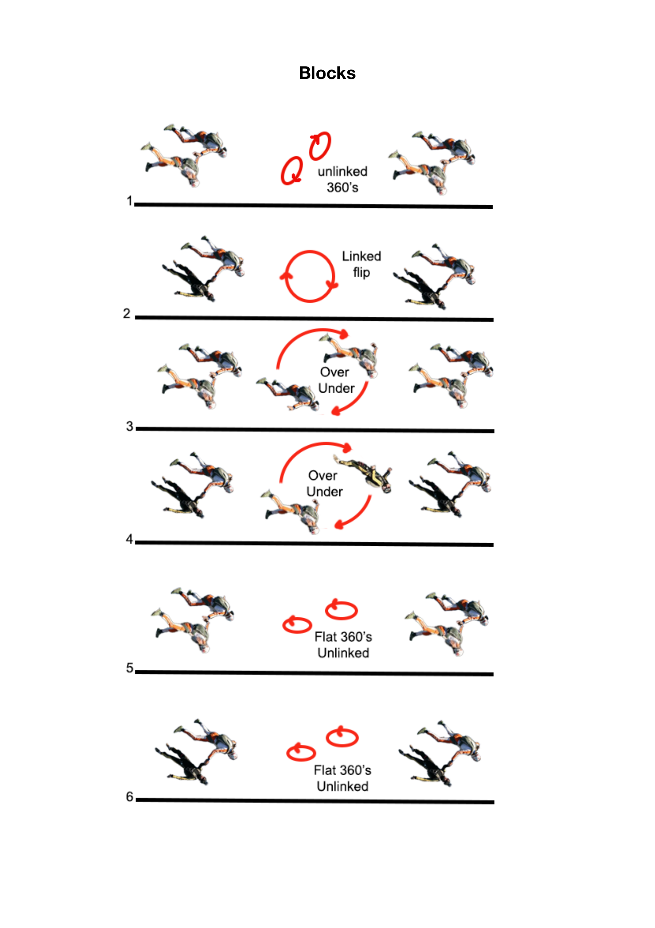

Blocks 7–12 (head-up angle orientations):
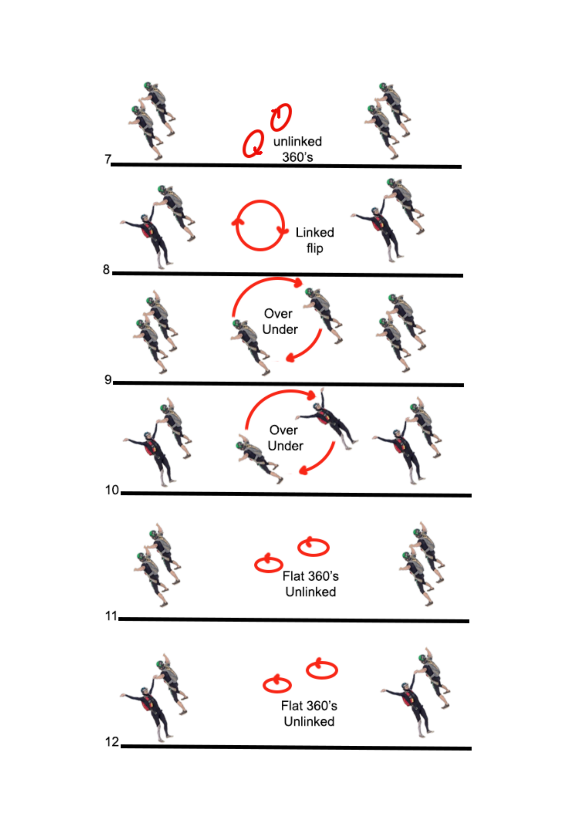
Blocks 13–18 (mixed head-up/head-down and through-the-vert):
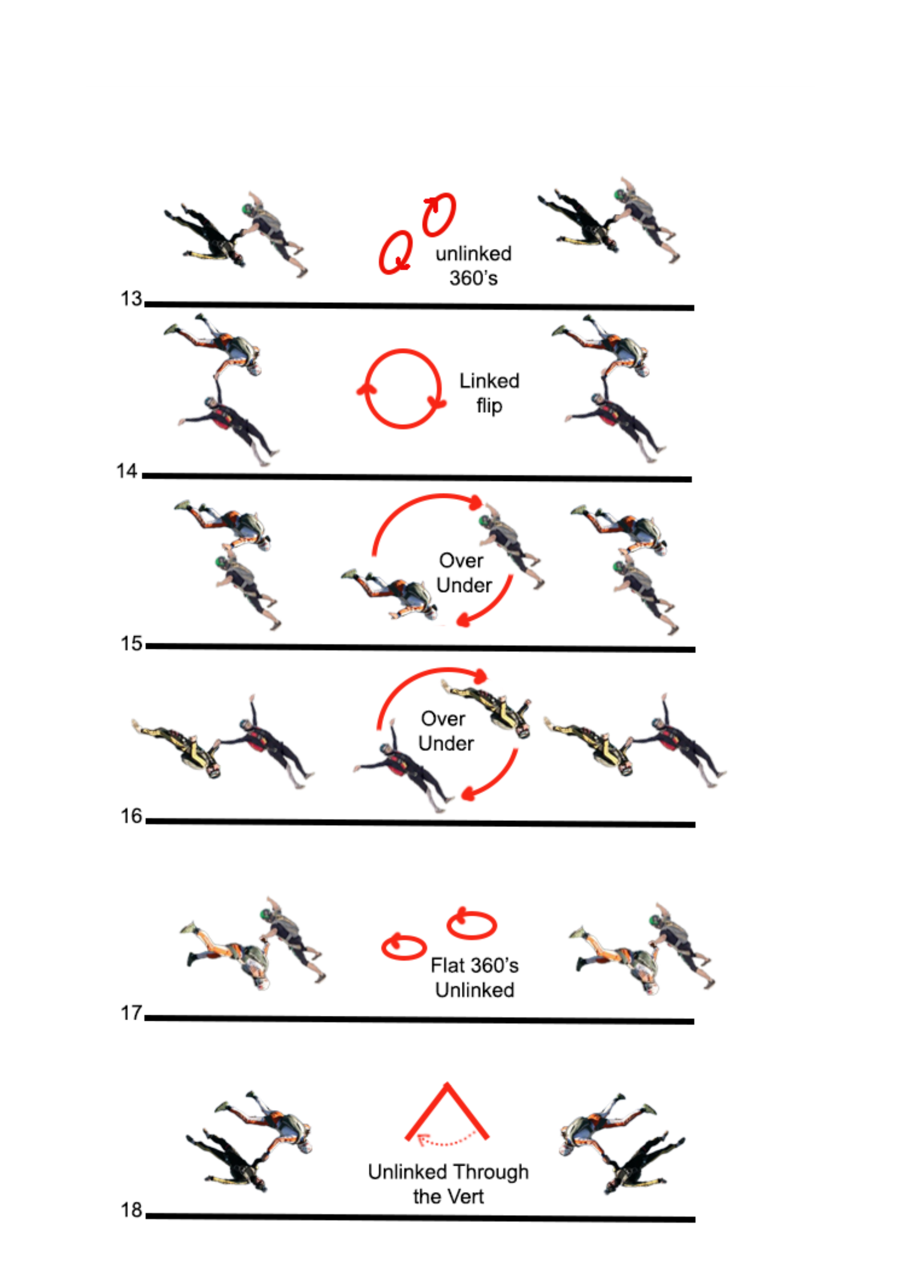

6.4 Blocks — Descriptions
Each block consists of a predetermined sequence of manoeuvres flown in formation. All blocks must be performed while actively flying an angle line and must meet the same video and docking visibility standards as randoms.

No. | Name | Description
1 | Both Belly — Unlinked 360s | Belly HD angle; opposite hand dock. Both unlink, perform 360° barrel roll, relink.
2 | Belly & Back — Linked Front Flip | One back one belly; same side hand dock. Back performs backward rotation, belly performs forward rotation. Grips maintained throughout.
3 | Both Belly — Over and Under | Both belly; opposite hand dock. Release grips, one flyer goes over/under in full rotation back to original slot, redock.
4 | Back & Belly — Over and Under | One back one belly; same side hand dock. Release grips, flyers over/under full rotation back to original slots, redock.
5 | Both Belly — Flat 360s | Both belly; opposite hand dock. Release grips, each performs individual flat 360° turn, return to slot, redock.
6 | Back & Belly — Flat 360s | One back one belly; same side hand dock. Release grips, each performs flat 360° turn, return to original slots, redock.
7 | Both Belly HU — Unlinked 360s | Both HU belly; opposite hand dock. Both unlink, perform 360° barrel roll, relink.
8 | Belly & Back HU — Linked Front Flip | Both HU; one back one belly; same side hand dock. Back performs forward rotation, belly performs backward rotation. Grips maintained.
9 | Both Belly HU — Over and Under | Both HU belly; opposite hand dock. Release grips, over/under full rotation, return to original slots, redock.
10 | Back & Belly HU — Over and Under | Both HU; one back one belly; same side hand dock. Release, over/under full rotation, return to slots, redock.
11 | Both Belly HU — Flat 360s | Both HU belly; opposite hand dock. Release, each performs flat 360° turn, return to slot, redock.
12 | Back & Belly HU — Flat 360s | Both HU; one back one belly; same side hand dock. Release, individual flat 360° turns, return to original slots, redock.
13 | Belly HU & Back HD — Unlinked 360s | One back HD one belly HU; opposite hand dock (R→L or L→R). Both unlink, perform 360° barrel roll, relink in original slots.
14 | Belly HD & Back HU — Linked Flip | One back HU one belly HD; opposite hand dock. Both perform forward rotation back to original position. Grips maintained throughout.
15 | Belly HD & Belly HU — Over Under | Both belly; one HU one HD; same side hand dock. Release, over/under full rotation, return to slots, redock.
16 | Back HU & Back HD — Over Under | Both back; one HU one HD; same side hand dock. Release, over/under full rotation, return to slots, redock.
17 | Belly HD & Belly HU — Flat 360s | Both belly; one HU one HD; same side hand dock. Release, individual flat 360° turns, return to original slots, redock.
18 | Belly & Back — Through the Vert Unlinked | One back one belly; same side hand dock. Release, both fly through head-down orientation to opposite position. Retake grips on arrival.

7. Safety and Conduct
- All competitors must follow DZ and APF safety standards.
- Exit order, direction, and break-off altitudes must be pre-briefed with the pilot and DZSO.
- Any behavior that compromises airspace safety or disrespects competition integrity may result in disqualification.

8. Amendments and Updates
This rule book is a living document and may be updated to reflect developments in the discipline or safety practices.

Any changes will be communicated through official channels and must be implemented before the following competition season.

Acknowledgement
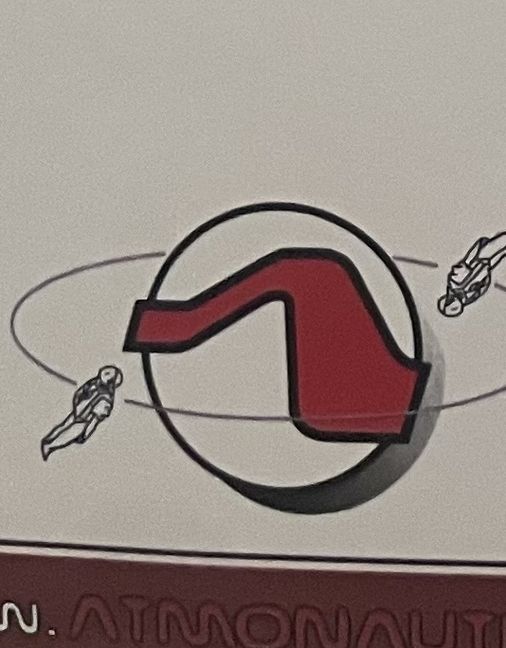 | This dive pool was inspired by the original Atmonauti discipline and dive pool concept developed by Marco Tiezzi, Atmonauta Instructor N. 01/08, and Gigliola Borgnis, Atmonauta Instructor N. 02/88, of Atmonauti.com.  Mason Corby (Atmonauta Instructor-Master Navigator N. 18, qualified at F2 Ballina) built upon this foundation to develop the angle flying formations and competition structure presented in this document. Full credit to Marco Tiezzi and the Atmonauti team for the original vision that made this possible.

© Downunder Dynamics | Angle Flying Competition Rule Book | All rights reserved.

